Lead in Drinking Water Website Content for Utilities

Lead and Drinking Water
Lead is NOT present in the City of Sandwich’s source water (groundwater), nor is Lead in the City’s treated drinking water. However, if homes and buildings have water service lines made of Lead, Lead can enter the drinking water through the corrosion of those plumbing materials.
The water service line runs from the water main to the water meter (see diagram). A valve, commonly referred to as the curb stop, controls the flow of water from the water main to the dwelling. In most cases this valve is located at, or near, the property boundary. The water main and the portion of the service line outside the property boundary is owned and maintained by the City of Sandwich. The service line located inside the property boundary is owned and maintained by the property owner.
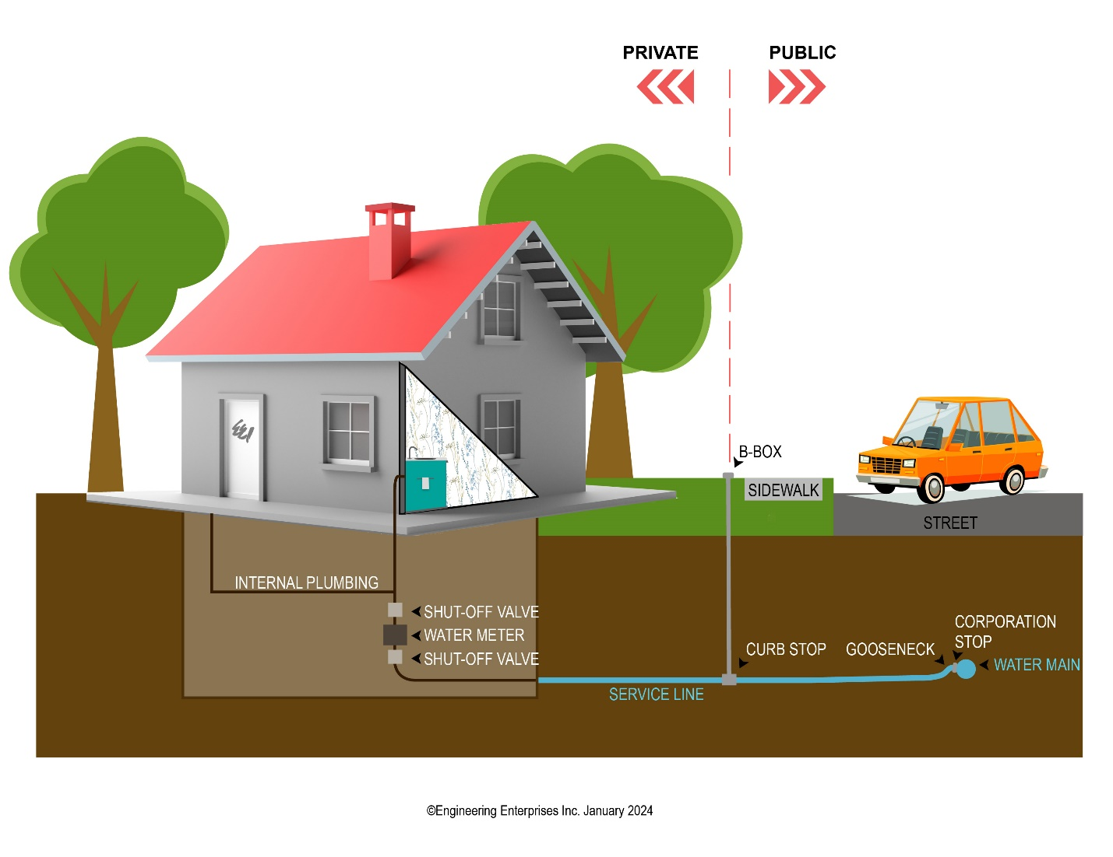
Lead was used in our community until ####
- If your home was built after ____, your service line and household plumbing are most likely not made of lead.
- If your home was built before ____, you may have a lead service line or service line containing lead solder.
Lead and Drinking Water Information
How to Identify Your Private Water Service Line Material
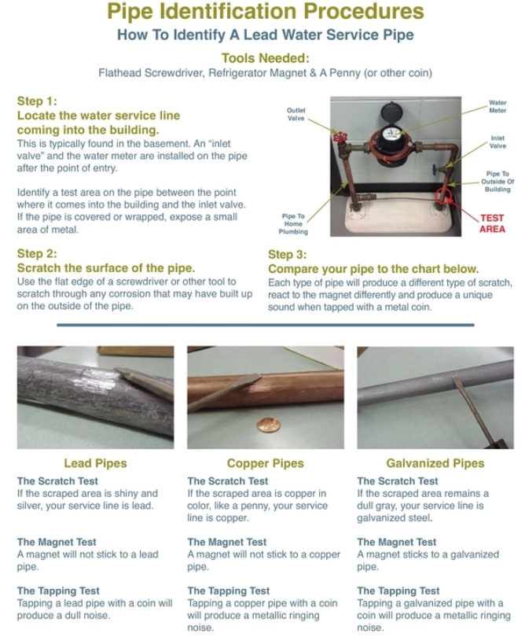
If you would like to help us identify your Private Water Service Line Material, please click here [https://survey123.arcgis.com/share/8bcf7d480e7c4c078e7bcdefecb2e17b] to report your findings.
Lead and Copper Rule
The City of Sandwich is in full compliance with the Lead and Copper Rule (LCR). This rule requires that a utility sample water from resident’s kitchen cold water tap that has been in contact with the internal plumbing for 6 hours. The City is on a reduced monitoring schedule which takes place every three years as a result of many consecutive years of compliance with this program.

Corrosion Control
The City of Sandwich has source water that is naturally hard (calcium carbonate), and has a neutral pH. The minerals that cause hardness coat the inside of your internal plumbing. This coating prevents lead from dissolving into drinking water.

Steps to Reduce Exposure to Lead in Drinking Water
Despite our best efforts to control water corrosivity and remove lead from the water supply, lead can still be present in some homes or buildings. Advice for lead safe water practices include:
- Before using any tap water for drinking or cooking, flush your water systems by running the kitchen tap (or any other tap you take drinking or cooking water from) on COLD for 1-2 minutes.
- Remove and clean faucet aerators regularly to eliminate any debris such as metal particulates.
- Purchase or lease a home water treatment device. Various types of water treatment devices are certified for household use and can remove a broad range of contaminants from water – including lead. Any type of water treatment device that you choose should meet National Sanitation Foundation (NSF) standards 42 and 53 for reduction of lead and particulate.
- Test water in houses with older plumbing. For more information on having your water tested by a certified lab, please call (815) 786-8802.
For more information on Lead, visit the Illinois Department of Public Health website and their Environmental Health Fact Sheet on Lead in Drinking Water

Lead Service Line Replacement Program
Planning for the Lead Service Line Replacement Program throughout the City of Sandwich has commenced. The Lead Service Line Replacement Program is partially financed by the Public Water Supply Loan Program (PWSLP) State Revolving Fund (SRF). The SRF program is administered by the Illinois Environmental Protection Agency and receives a portion of its money to fund these types of projects from the US Environmental Protection Agency. This program will eventually include the replacement of identified lead service lines throughout the City, although financing is still being determined. Once complete, it will improve water quality for area residents and businesses, as well as remove any health and safety threats with the lead services. SRF programs operate in each state to provide communities the resources necessary to build, maintain, and improve the infrastructure that protects once of our most valuable resources: water.

Lead Service Line Identification Map
The City of Sandwich has launched an Interactive Lead Service Line Identification map to help minimize our customers’ exposure to lead in water. This map will help assist customers in identifying where lead service lines are located and provide residents and businesses with information regarding publicly-owned and privately-owned water service lines.
Customers can simply click on the water drop located within the map to obtain information about their service. Click here to access this interactive map.
https://www.arcgis.com/apps/dashboards/a9e2e326e5f1450d9cccb04ca046e58f

Voluntary Lead Service Line Replacement
The City of Sandwich Water Utility encourages the full replacement of lead service lines on both public and private property. Property owners interested in replacing a lead service line can work with the Water Utility to replace the entire service line from water main to meter. If a property owner meets specific requirements and agrees to pay for the service line replacement on private property, the City will coordinate and replace the portion in the public space at the same time.
For more information about voluntary lead service line replacements, contact Brian Voelkel at (815) 786-8802.

Additional Resources
For more information about Lead click here for U.S. EPA information on Lead.
For more information about Lead click here for American Water Works Association (video): Together, Let's Get the Lead Out.

